Raspberry Pi
Web Server & HTML Tutorial
Tutorial by Andrew Oakley
Public Domain 28 Jan 2017
www.cotswoldjam.org

The Terminal
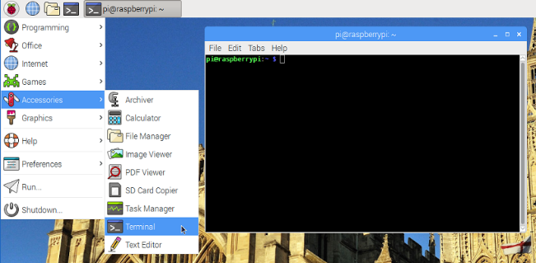
Start the terminal with the Raspberry Pi menu – Accessories – Terminal.
We’re going to install a web server. A server is a program that other people can connect to.
The ordinary user pi doesn’t have the ability to install software, so we use the sudo command to temporarily switch to the superuser (also known as the root user). Enter:
sudo apt update
sudo apt upgrade
Update gets an up-to-date list of software. Upgrade installs new versions of any out-of-date software you have. If you are on a slow internet connection, upgrade might take a long time. You might be asked to confirm by pressing Y and Enter.
Now let’s install the Apache web server, the most commonly used Linux web server.
sudo apt install apache2
You’ll see that this asks to install apache2 and a few other programs too. These are called “dependencies” – they are programs which apache2 needs in order to work.
Once Apache is installed, start your web browser. On a Raspberry Pi 2 or 3, you can use the Pi menu – Internet – Chromium web browser.
If you are on an older Pi 1 or Pi Zero, select Pi menu - Run – and then type epiphany and press Enter. Epiphany is a simpler browser for slower computers
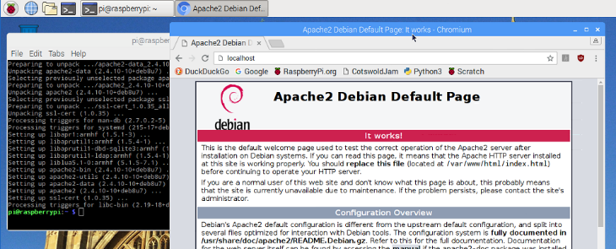
In the web browser’s address bar, type localhost and press return.
You should see the Apache2 Default Page.
localhost always refers to the computer you're using. So if someone types it into their Raspberry Pi, it'll refer to their Raspberry Pi and not yours.
Go back to the terminal and enter:
hostname
It will tell you the name of your computer. This might be raspberrypi or someone might have customised it for you, such as rpi-ab12 . Now go back to your web browser, and type:
hostname.local
… where hostname is the name of your computer. You must put .local afterwards on Linux computers. On Microsoft Windows, you’d use .lan instead: hostname.lan
Provided you don't have the same hostname as someone else on the same network (usually “your network” means “your building”) then this should find only your computer. This is called Zeroconf and is also known as Avahi or Bonjour. Some computers don't support Zeroconf so you can find our your IP address instead:
hostname -I
(note capital i) Your IP address will look like four sets of numbers, such as 192.168.0.42. Now try browsing to your IP address in the web browser.

Creating your own web page in HTML5
Back in the terminal, enter:
cd /var/www/html
ls -lh
/var/www/html is where web pages are kept. You should see index.html. We're going to rename it to -old (to keep a copy, just in case) and create a new index.html of our own.
sudo mv index.html index-old.html
sudo leafpad index.html
A text editor program should pop up, with a blank page. Start typing:
<html>
<head>
<title>My first web page</title>
</head>
<body>
<p>
Hello world
<p>
My name is Andrew
</body>
</html>
Change Andrew to whatever your name is, and save the page with File menu, Save.
Reload the web browser using the reload button, near the address bar.

What did this code do?
<html> tells the browser this is the start of a web page; </html> is the end
<head> says this is the start of the header, where the title goes; </head> is the end
<body> is the start of the text of a web page; </body> is the end
<p> is the start of a new paragraph; the closing tag </p> is optional in HTML5
index.html is a special file name that gets loaded if you don't specify a particular web page inside a folder. So http://localhost is the same as http://localhost/index.html
Under "My name is Andrew" now type:
<p>
<a href="pet.html">My favourite pet</a>
Don’t forget to File, Save, then reload browser.
<a> is a link to another web page (or any file on a web browser). The href (hypertext reference) can be "relative" such as pets.html - this will become http://hostname.local/pets.html because pets.html is in the same folder as index.html
To link to web pages in other folders on other computers, you can use an "absolute" address such as: http://www.bbc.co.uk/news/technology-37305200
Close Leafpad with the X at top right. We’re going to add a photo. Let’s list the photos (if you’re not using the Cotswold Jam preinstalled SD card, you’ll need to find your own photos):
ls -lh /home/pi/Pictures/pets
Pick a pet (cat, dog, guinea pig, hamster) and copy the picture to the web server directory:
sudo cp /home/pi/Pictures/pets/cat.jpg /var/www/html
Create a new web page with: sudo leafpad pet.html
<html><head>
<title>My favourite pet</title>
</head><body>
<p>
My favourite pet is:
<p>
<img src="cat.jpg">
</body></html>
Reload browser and click on the "My favourite pet link". You can use the Back button to go back to the index page.
Now try browsing other classmates' websites. You will need to know their hostname or IP address. For example http://rpi-12ab.local or http://192.168.0.123
If your hostname is raspberrypi (the default) then that might clash with other similarly named computers. You can change it by going to Pi menu - Preferences - Raspberry Pi Configuration and changing the Hostname. You'll be prompted to reboot your machine when done.
If you want to uninstall Apache: sudo apt remove apache2 && sudo apt-get -y autoremove

