Raspberry Pi
Python GPIO Zero
Simple LED Tutorial
Tutorial by Andrew Oakley
Public Domain 24 Sept 2016
www.cotswoldjam.org

The electronics
A Light Emitting Diode (LED) is a light bulb with a short leg and a long leg. If you feel around the rim, you'll also find a flat edge. The short leg and flat edge always connect to negative (ground).

LEDs always need to be connected with a resistor. If you connect them without a resistor, they will burn out and probably won't work again.
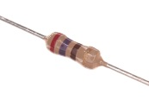 | The resistor can be connected any way around. Lower value (lower Ohm) resistors will allow more current through and will make the LED brighter; higher values will let less current through and make it dimmer.  Any resistor between 220 and 470 Ohms will work fine.

You should also have two short and one long jumper wire (all "female to female" - holes at both ends).
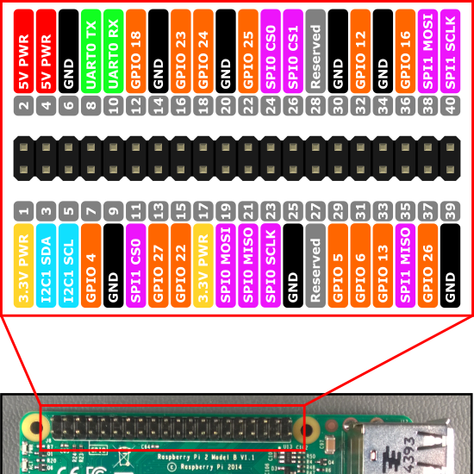
Connect one short wire to GPIO 4. This is the 4th pin from the left of the bottom row.
Place the resistor in the end of the short wire.
Connect another short wire to the resistor.
Connect the end of this short wire to the long leg of the LED. This is the positive connection.
Next, connect the long jumper wire to ground (negative, GND). There are several ground pins on the Raspberry Pi, for example the 5th pin from the left the bottom row.

The program
Power up your Raspberry Pi. From the desktop menu, select Programming - Python 3 (IDLE). Then use File, New Window to create a new program.
Type in the following program, or alternatively you can use File, Open to open the led.py program in the python/led folder.
from gpiozero import LED
from time import sleep

led=LED(4)
led.on()
sleep(1)
led.off()
Use File, Save to save this program as led.py and the run it by selecting Run menu, Run Module.You should see the LED light up for one second, and then turn off.
Not working? Check you’ve got:
- The correct GPIO pins
- The LED is the correct way round; short leg to ground (GND)
- No spelling mistakes, no missing brackets, and you’ve used round brackets instead of pointy, curly or square ones.

What is this program doing?
from gpiozero import LED
from time import sleep
The first two lines tell the computer to learn about a new thing. Computers can learn from programs that other people have written, and we call these other programs "libraries". Our instructions tell the computer to learn about LEDs from the GPIOZero library, and learn about sleeping from the time library.
led=LED(4)
We then create an LED object. We say that the LED is connected to GPIO 4.
led.on()
sleep(1)
led.off()
Turn the LED on, wait for 2 seconds, then turn it off.
See if you can flash SOS in Morse code. Have a look at the led2.py program and learn about the led.blink() command.

