Raspberry Pi
Python GPIO Zero
Screaming Jelly Babies
Tutorial by Andrew Oakley - Public Domain 24 Sept 2016 - www.cotswoldjam.org
You will need speakers or headphones to use this tutorial. You will also need a .wav sound file; you can download some sounds and the program from: www.cotswoldjam.org/tutorials

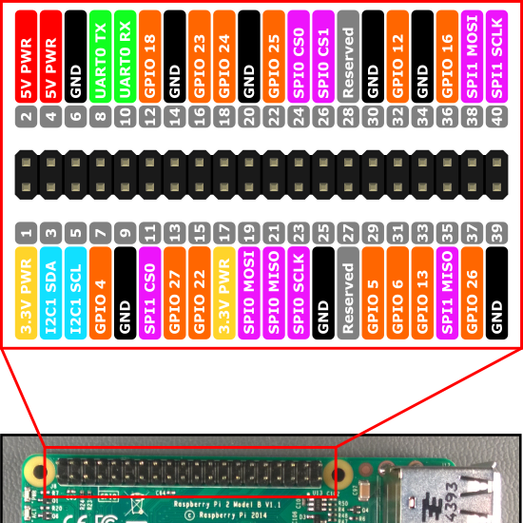
The electronics
You should have two jumper wires (both female-to-female, holes in both ends) and two paperclips.
Straighten out the paperclips
Push a paperclip into one end of each jumper wire.
Connect the other end of one jumper wire to GPIO 4. This is the 4th pin from the left of the bottom row.
Next, connect the other end of the other jumper wire to ground (negative, GND). There are several ground pins on the Raspberry Pi, for example the 5th pin from the left the bottom row.
Now poke the paperclips into the jelly baby diagonally, so they cross over in an X pattern. You want them to overlap very closely, but not quite touch.

The program
Power up your Raspberry Pi. From the desktop menu, select Programming - Python 3 (IDLE). Then use File, New Window to create a new program.
Type in the following program, or alternatively you can use File, Open to open the scream.py program in the python/jellybaby folder.
from time import sleep
from os import system
from gpiozero import Button

button = Button(4)
print ("Don't hurt me!")
while True:
button.wait_for_press()
print ("Ouch!")
system("omxplayer scream-c.wav")
Use File, Save to save this program as scream.py in the python/jellybaby folder (it must be saved in the same folder as your .wav files) and then run it with Run menu, Run Module.
Now squish your jelly baby! As the two paperclips touch, you should hear a little scream.
To stop the program, select Shell menu, Restart Shell.
Not working? Check you’ve got:
- The correct GPIO pins
- Two spaces at the start of lines which need spaces
- No spelling mistakes, no missing brackets, and you’ve used round brackets instead of pointy, curly or square ones.

What is this program doing?
from time import sleep
from os import system
from gpiozero import Button
The first three lines tell the computer to learn about new things. Computers can learn from programs that other people have written; we call these other programs "libraries". Our instructions tell the computer to learn how to run other programs (such as the sound player) from the system library, and how electrical buttons work (two wires touching) from the GPIO Zero library. We're not actually using the sleep command yet, but you might later.
button = Button(4)
We then create an Button object. We say that the button is connected to GPIO 4.
print ("Don't hurt me!")
while True:
We print a message to the screen, then start a loop that repeats forever.
button.wait_for_press()
print ("Ouch!")
system("omxplayer scream-c.wav")
Next we wait until the wires touch, print a message and then play the sound file.
There are other sound files. Can you get it to play Doh-Ray-Me with little screams? What about Mary Had A Little Lamb? Use sleep(1) to wait for a second between sounds.

